May is Mental Health Awareness Month
Email Signature Instructions:

Hover over the name in the signature, then right click on the cross icon like the example below.

Select copy, and then paste into the edit signature box in you outlook options.

Video tutorial

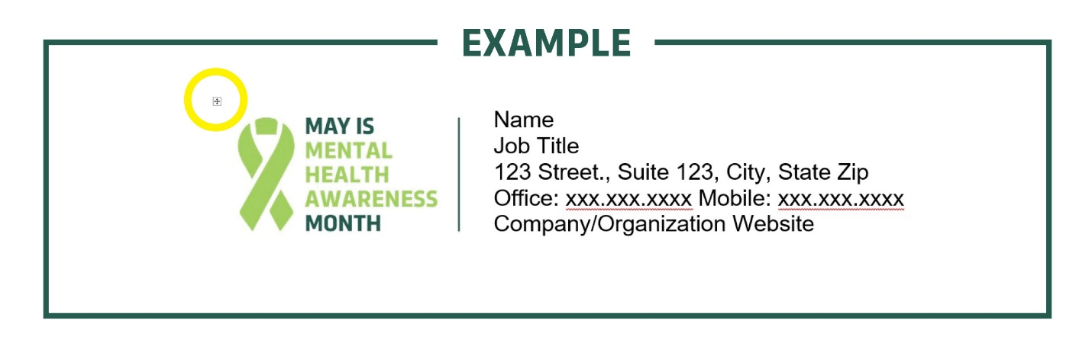

Signature to copy:

Name
Job Title
123 Street., Suite 123, City, State Zip
Office: xxx.xxx.xxxx Mobile: xxx.xxx.xxxx
Company/Organization Website

